OCR GCE A
COMPUTER SCIENCE PROJECT
H446-03

Name : Osman Jalloh

Candidate Number : 4450
HAYDON SCHOOL : 12924
Title of Project : Student grade management system

H446-03 – Project CONTENTS
Table of Contents
A. Analysis 3
B. Design 3
Systems diagram 3
C. Developing the coded solution (“The development story”) 3
D. Evaluation 3
Project Appendixes 4

A. Analysis

Introduction:
For my NEA I’m doing a student grade management system that allows teachers and other members of staff to input, store and search student grades. The project would be coded on python and would have clearly defined inputs such as student names, ID’s, subjects/ subject grades and the staff members command inputs like “add student” or “view average grades”. The program would be able to handle multiple students' grades allowing for scalability. The tasks involved in this project follow processes with clear deliverables such as “finding the mean, highest and lowest grades” and converting grades from numerical to letter values based on the grade boundaries for different subjects. The student grades and other information based on them will be represented using classes and lists allowing for each student to become an object of a class called “Student” which contain attributes such as their name and grade and the list data structure can store a lot of student objects. Further implementation of OOP would also be done.

How it is solvable using computational methods:
The problem is solvable by using decomposition where I will be breaking down the grades into smaller and more detailed pieces of information regarding that particular “grade”. This is needed because defining aspects such as subjects and grades will make the project easier and manageable to create. The second thing I would make use of is polymorphism since in the database manager, the teachers need to manage different types of users (students and teachers) with each having different functionalities for example “students view grades” or “teacher inputting grades”

Stakeholders:
Suitable stakeholders would include teachers mainly teaching GCSE based subjects, since the minimum number of subjects a student takes for their GCSE is 5 whilst teachers that mainly teach A - level students normally have students taking 3 A - levels so there would be more grade assessing for students doing their GCSE’s since they typically study more subjects, this can help the teacher identify students that are top performing or underperforming. Another stakeholder would be the students since they can benefit from getting feedback from their teachers and how they can improve their learning by boosting their grades.

Research (For existing solutions):

Example 1 - SIMS database app
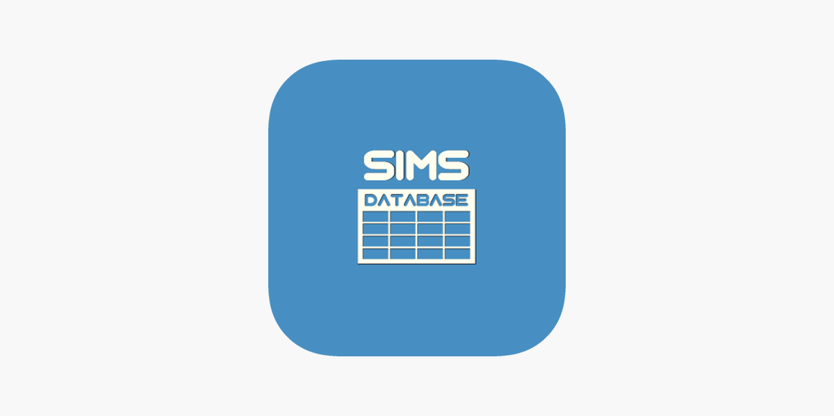
Existing solutions for a student grade management system are SIMS, openSIS and Gradelink.

SIMS is very good in terms of its functionality where it helps the user manage administrative tasks, track student data and improve learning outcomes, It provides tools for areas with high complexity such as pupil tracking, attendance, admissions, communication with parents via automated/ manually written messages and can create statutory reports. Unlike basic databases that may rely on password protection in of itself, SIMS can offer reliable security frameworks that can act as another layer for password protection.
Pros/Positives | Cons/Negatives
- Access based on different roles  - Good data security  - Necessary components for functionality | - Complex  - Expensive (My solution would be open source since its my project)

Example 2 - OpenSIS

OpenSIS is a cloud running student information system that provides a set of tools for managing student data, grading, attendance, communication between teachers and other members of staff while also combining learning management systems such as canvas and moodle. It offers data entry fields with almost unlimited custom fields, WASH - water, sanitation and hygiene info and also school address entry with automatic google maps integrated in the system.

OpenSIS is mainly known for its open source roots, affordable pricing, mobile user friendly design with the software built on microsoft azure.

Pros/Positives | Cons/Negatives
- Affordable and flexible  - Customisation support  - Tracks attendance  - Communication with parents and teachers | - Big learning curve for teachers unfamiliar with the software  - Complexity for small schools  - Limited functionality for the “free” version

Example 3 - SchoolCues

SchoolCues is also a cloud based school management system similar to openSIS mainly designed for schools that are low budgeted or to streamline administration, boost parent engagement for communication and simplify daily operations. Key features are that it includes payments, online admissions, attendance tracking and an online gradebook. This cloud based management system is mainly known for its affordability and easy maintenance for small schools.

Pros/Positives | Cons/Negatives
- Online gradebook  - User friendly  - Data tracking and reporting | - Limited scalability  - Less suited for higher education e.g. colleges/ universities would find it not too helpful  - Basic features compared to other database systems i.e. SIMS

Questionnaire for my stakeholders:

- Group - Teachers
Q1. What type of student information do you need quick access to frequently?
I would like to be able to access students’ grade information

Q2. How would you like to input or update student information?
I would like a system that enables

Q3. How important do you think data security is for your role?
Very important as some student information must be kept confidential so that other students

Q4. Would you rather have a simple interface with core features or a system with a variety of options?
Core features.

- Group - Students

Q1. Do you think being able to communicate with teachers or view feedback from them would be beneficial?
Being able to view feedback from teachers would help students asses what they are doing right as well as what they are not doing right. This would cut down on the continual need to ask the teacher in person, enabling students to keep track of their progress.

Q2. What information would you like to check in your profile e.g. Grades/ progress
Students are interested in viewing their grades over various subjects, overall assessment over time, and written comments by the teachers. Looking at previous grades can assist in discovering strengths and weaknesses.

Q3. What kind of design would be better for you (mobile user friendly/ clean layout/ PC user friendly)
The layout should be clean and simple, clear menus, and not cluttered. Having mobile access would also be useful as students could just check their grades on their phones.

- Group - IT/Technical staff

Q1. How should the data be stored (cloud/ local database)
For a small-scale system, a local database would be sufficient as it is easier to manage and does not rely on an internet connection. Cloud storage may be considered for larger systems but introduces additional complexity and security concerns.

Q2. Do you want to control the levels of access
Yes, access control is very important. Different users should have different permissions, for example administrators managing users, teachers managing grades, and students only viewing their own information.

Q3.What problems have you encountered with other similar systems such as SIMS
Existing systems can be overly complex, slow to navigate, and difficult to maintain. Some systems include unnecessary features that make simple tasks more time-consuming.

Q4. Do you prefer systems that are easy to maintain or complex systems with more features
An easy-to-maintain system is preferred, especially for schools with limited technical staff. A simpler system with essential features is more reliable and easier to update or fix.

Features to implement:
Having done a questionnaire with my stakeholders, I have come up with with a scope of features that I intend to implement into my solution

Feature: | Description: | Justification:
Add/ Modify/ Delete student records. | Allows teachers or admins to create student profiles, update existing data and remove outdated information if a student has left the school. Demonstrates error handling and validation | This is the foundation of a student database since without this feature the system would not be functional.
Search and filter | Users would be able to search for a student quickly by their ID, name or class. This demonstrates algorithms for linear and binary search and data structures such as lists. | Saves time for teachers/admins when going through large quantities of data making the program more efficient and and less time consuming when searching for specifics.
Grade records | The system will store student grades for multiple subjects and calculate averages to label which students are “Well performing”, “Decent”, or “Under performing”. Involves calculation and algorithms that include sorting | It gives teachers an overview of their students' academic performance and also gives students hindsight on what level they are at and how to improve/ stay at their current one if they feel like they’ve done well.
Role-based logins | Different types of users log in with their own unique functionality built for them depending on their rights for certain access. Polymorphism applies here with different user classes linked with a parent user. | It makes sure that there is data security and prevents students from purposefully changing grades to their benefit.
Statistical average | Gives an average of all the combined students’ grades and makes it into a final grade depending on the number of “points” each grade has. | It allows students to know where they are at in terms of grade performance and deduces what they should do to improve their grade.
Data tracking and reports | Reports produced include students’ grades, attendance, progress tracking and their overall performance over a term. | This would allow for students to see their performance as a whole and take the steps to maintain or improve what they have achieved.
Providing feedback | Providing feedback for a students’ work allows them to see their “what went well” (WWW) and their “even better if’s” (EBF) so that they can annotate their past work to fix the errors in their answers. | Benefits students and gives them the necessary steps to take when.

Limitations:
Although the system will successfully implement core features such as CRUD, search and filter there might be some limitations. For example, the system might lack advanced security measures, searches are only exact matches and do not give further information/suggestions based on the user’s search or search history. The program may not be able to support a large amount of school data due to file storage and may not include password protection. It would only be designed for local use. The solution would run on any system that has python installed and since it will only be designed for local use there won't be a need for internet connection.

Hardware and software requirements:

- Hardware requirements

Component | Requirement | Justification
Processor | Intel i3 or better | Good enough to run development IDE without any lag spikes/ lagging.
RAM | 4 GB (minimum) | Allows for no slowdown whilst testing with programming tools
Storage | 1 GB free storage | For storing the database and project files
Input devices | Mouse and keyboard | Data entry is necessary

- Software requirements

Software: | Type: | Justification:
OS (Operating system) | Windows 10/11 | To allow a minimal amount of errors or bugs in the project due to outdated versions of the computer/software
Programming language | Python | Chosen for OOP (object oriented programming) and its easy implementation of polymorphism.
Code editor | Pycharm | Provides tools for debugging and testing.
Database | JSON | Most compatible with python since it's easy to implement and supports CRUD operations.

The system should be able to run on standard hardware so that it can be accessible to as many users as possible.

Success criteria:
The system would be optimal and functional for all stakeholders involved in this project and that the solution would be able to show the aspects of all the features that would be implemented into the system e.g. search and filter, role based logins and grades, in the form of python code that will include polymorphism, decomposition and error handling to enable efficient use of object oriented programming methods. The success of my student grade management system (SGMS) would be done by evaluating my stakeholders satisfaction, usability, functionality and performance.

Criteria: | Reasoning:
Stakeholders | Stakeholder satisfaction will be assessed by my stakeholders feedback which would confirm whether the solution meets their expectations and needs of students, teachers and admins (IT).
Usability | Usability would be measured by the quality of the user interface and user input.
Functionality | Functionality would be measured by the core features which would be adding, modifying, removing, finding records, recording grades, and allowing different roles to access the system which would enable specific access rights to the user.
Performance | Performance would be tested by using a dataset of a decent number of students e.g. 15 - 50 students.
Questionnaires | The questions given to the user would allow

Advanced features may be added such as data visualisation if I have enough time.

B. Design

Systems diagram

Teachers

Course and content

Grade assignments and exams

Create/edit/add grade percentage and calculate average

Student management

Track student progress and performance

Provide feedback

Send grades
Admins

Assign roles

Role: Teacher

Role: Student

Reset

Reset: Password

Reset: User ID/ Network

Announcements

Monitoring and management

System usage

Generate statistics
Students

SGMS
View grades and feedback
Track course completion
Progress tracking
Structure of the design solution:
I have divided my system into 3 main categories which include admins, teachers and students. Each category would have different user access rights depending on their status and authority when using the system on their account. This is necessary because it ensures all authorised users can access and modify information of which is permissible to them, by allocating different access rights based on each role.

Admins/ Administrators have the highest level of access within the system, allowing them to manage user accounts, reset roles, reset login credentials and monitor system usage. This is necessary to ensure the system runs efficiently because admins are the ones responsible for maintaining data integrity and managing permissions. This way, the system would have reduced errors, improved reliability and ensured that all students and teachers are correctly configured according to their role.

Teachers would be able to view and manage their students' homework assignments so that they are able to provide feedback on students' work and would help them achieve a grade that at least meets their predicted grade. The system would prevent students from altering their own grades or feedback while allowing teachers to assess progress and to provide targeted support.

Students would have more restricted access, enabling them to view their homework assignments, grades, feedback and to track their overall progress/ course completion. This would allow students to engage more with their learning as they can identify their areas of improvement and take greater responsibility for their studies within a controlled and secured environment.

System decomposition:

From the systems diagram the problem has been decomposed into smaller and manageable sub systems. This approach would improve the reliability of the algorithm
itself by allowing the system to scale effectively as the number of users increases.

Classes/variables/methods/ attributes involved | Sub systems | Description | Reason as to why it is part of the system
User class would be used to store and manage the user’s data. Attributes include:  - userID  - username  - passwordHash  - role  Methods include:  - login()  - Password  - Role() | User authentication/ authorisation | Responsible for handling user login and access control. Verifies user credentials with the stored data and determines the user's role. System grants specific access to features and data. | Necessary to ensure system security and to prevent unauthorised users from accessing information they aren't supposed to access e.g. account management tools.
The Student class inherits from User and includes:  - submitAssignment()  - viewGrades()  - viewFeedback()  Each student object would store:  - assignments (list)  - grades | Student progress tracking | Tracks student progress based on their completed assignments and grades achieved, allowing students to monitor their overall performance. | This sub system certifies decomposing of progress tracking which allows statistics to be handled separately from the actual assignment management rather than both being merged together.
Admin class inherits from the User with methods such as:  - createUser()  - deleteUser()  - resetPassword()  - assignRole() | Administrative management | Allows admins (only) to:  - Create, update or delete user accounts  - Reset passwords  - Change user roles | Necessary to maintain the system’s integrity, role allocation and system performance
Assignment class will store assignment related data:  - assignmentID  - title  - description | Assignment management | Teachers would be able to create, edit and delete homework assignments. Students can view their assigned tasks and complete them. | Ensures assignment data is stored consistently and can be accurately tracked
The Submission class links students to assignments such as:  - submissionID  - studentID  - assignmentID  - submittedFile  - grade  - feedback | Grading and feedback | Helps teachers assess work, assign grades and write feedback. Grades are then validated before being stored to ensure they are within acceptable boundaries. Students can view their grades and feedback but can't modify them. | Separating grading logic would help with data integrity and prevent grade manipulation. This would also enable users to keep their data secured from corruption or accidentally data mishandling.

Iterative testing:

Test | Input | Expected | Actual
Add student | ID = N29 and Name = Bob | Student added | Pass
Duplicate ID | ID = N29 again | Rejected | Pass
Add grade | Maths = 7 | Stored | Pass
Invalid grade | 12 | Rejected | Pass
View average | Maths = 7, Computing =6 | Avg = 6.5 | Pass

Developing the coded solution (“The development story”)

C. Developing the coded solution (“The development story”)

1- User authentication

A hashing method would be required to ensure that the passwords would not be stored as plain text so that it reduces the risk of passwords being exposed if the data file is accessed without authorisation. For this part of the projects first iteration I used the SHA-256 algorithm combined with a randomly generated salt which was implemented using Python’s library. A salt is a random value added to the password before hashing, which ensures identical passwords do not produce the same hash. I was going to originally use “bcrypt” but I didnt go ahead with it. This is because the SHA-256 algorithm is already well understood and can be implemented using concepts covered in OCR A Level computer science. Although bcrypt offers strong protection against brute force attacks, this amount of security would probably not be required for a small scale system. This chosen approach would provide a balance between security and implementation.

Iteration 1.1

Objective
The purpose of this iteration is just for the imports and password hashing already implemented to the start of system run time.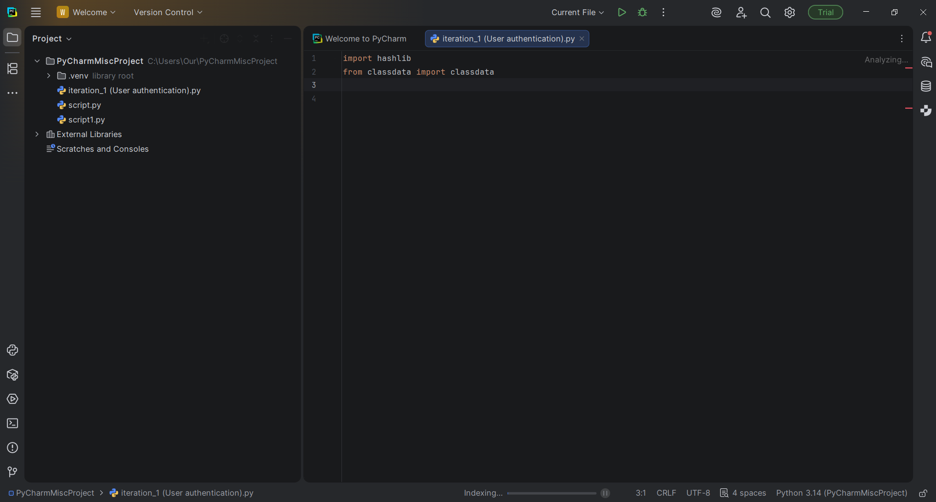

Description:
I started by importing the required python libraries. The “hashlib” library was imported to allow cryptographic hashing. Additional modules such as “classdata” were added to support object oriented design.

UPDATE:
Unfortunately there was no such thing as a built in “classdata” module in python. I resolved this issue by importing the actual built in module called “dataclasses”.

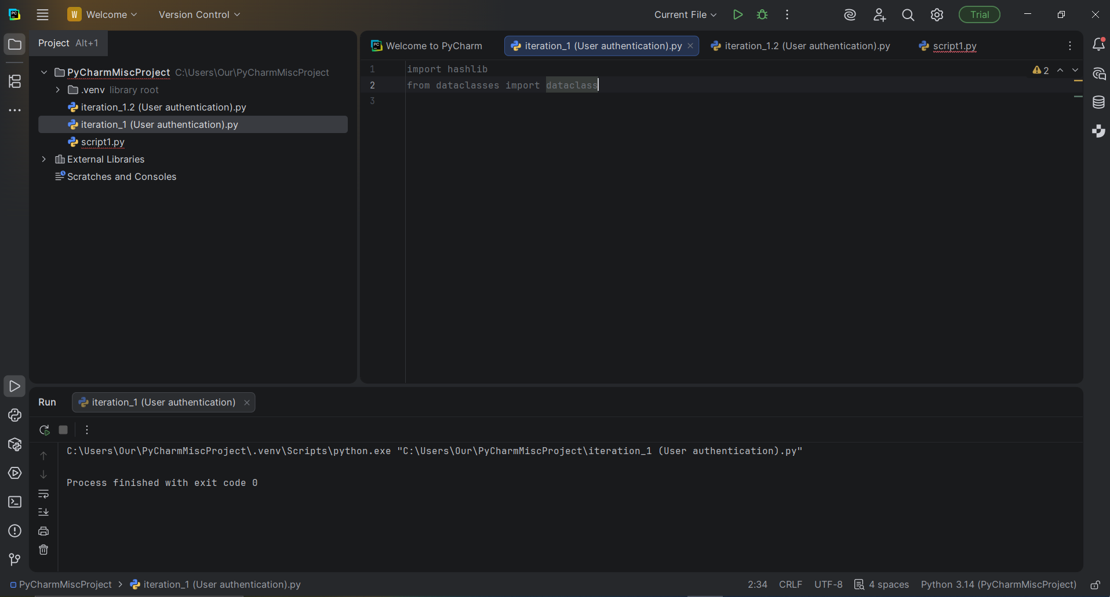

Testing:

Not needed.

Iteration 1.2

Objective
The purpose of this iteration is for two values to not give the same result (hash value) when given an input.

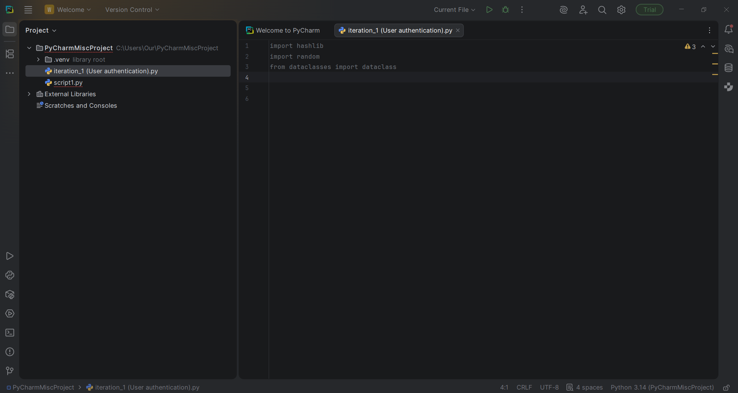
Description:
For this iteration I have added another module called “random” to generate random numbers by using a seed value.

UPDATE:
Due to my unfamiliarity with other modules that could potentially be better suited for password security I just stuck with one that I was already familiar with which was the “random” module. However I’ve done some research into finding the best modules for password security enabled me to substitute the “random” module with a module called “secrets” which is more ideal for password security whereas random would be more ideal for games/simulations.

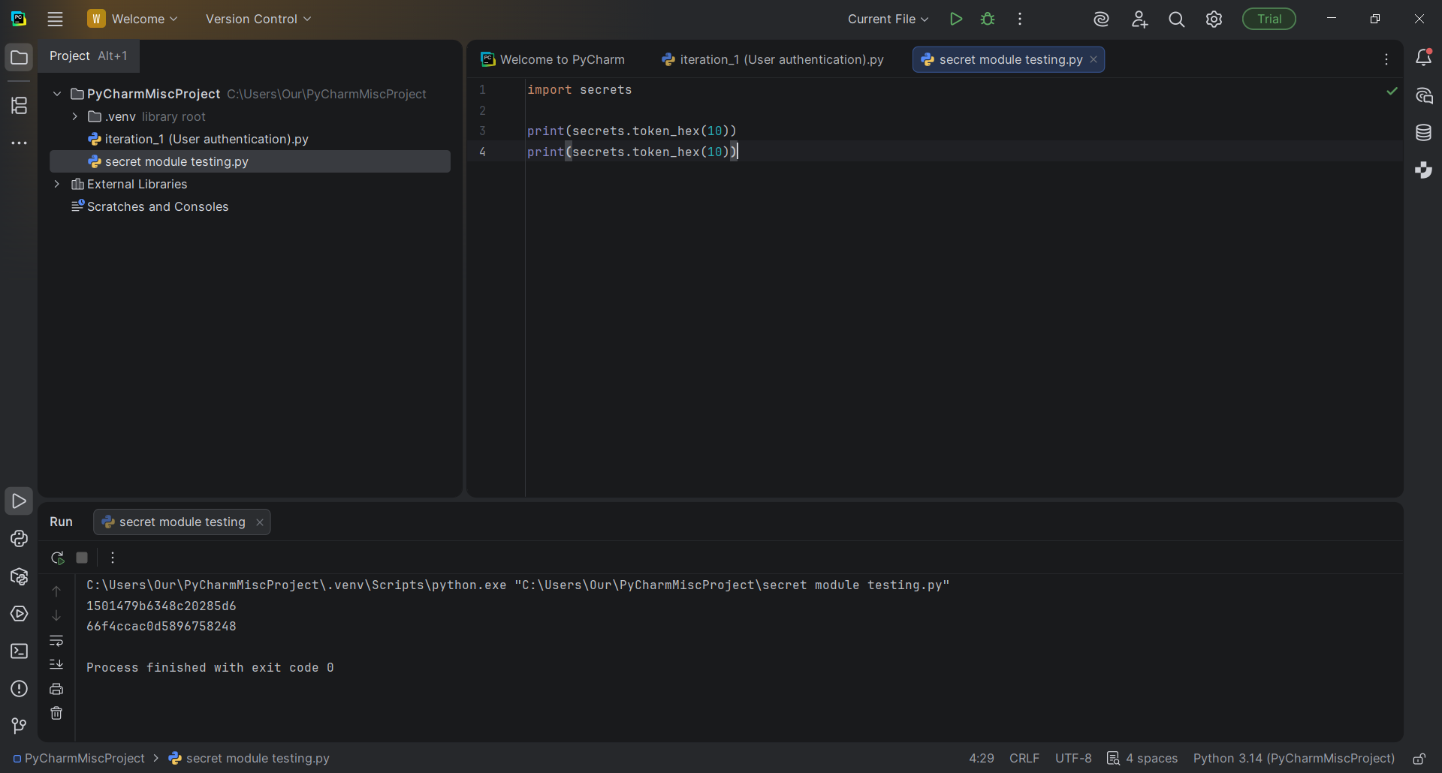

Testing:
Expected outputs - Different hash values
Actual Outputs - Different hash values

Assessment:
As shown from the image above, the result shows two different values. This means that the function outputs two different values each time and this also confirms that the “secrets” module will be useful for password salting.

Iteration 1.3

Objective:
For this iteration I have included in the hash function. The hash function would combine the user’s password with a RG (Randomly Generated) salt and produce a hash value to ensure that the passwords arent stored in plain text and that identical passwords must result in a different hash value.
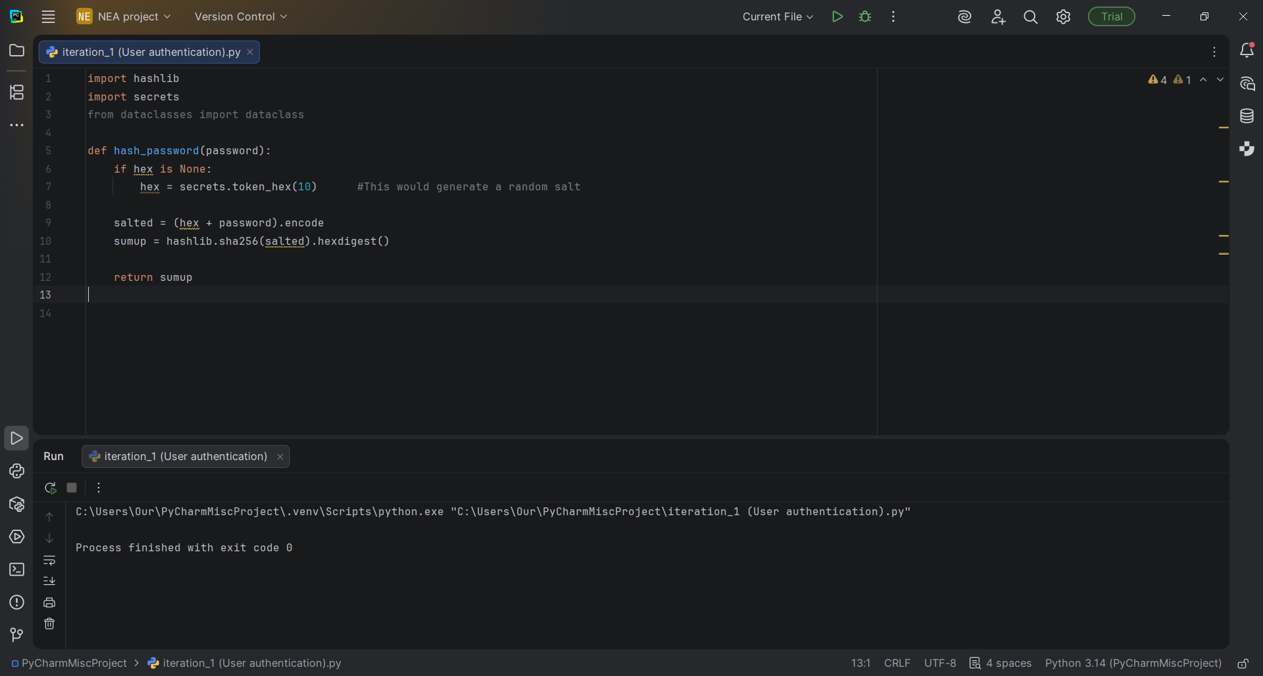

UPDATE:

Polished code to be more clear, and there were also few problems I’ve found out with the original code:

1. The actual value called “hex” isnt a parameter or variable in the function

In the above image “hex” is never passed in and hex is also the name of the built in python function meaning that this would cause confusion and would probably make it harder for me to verify the passwords later.

2. Only the hash can be returned but not the salt. If I generate a new random salt each time but dont store or return it I will never be able to recreate the same hash during login meaning that the password checking would also not be reliable.

3.The “.encode” method should be “.encode()” with parameters otherwise the method would be storing itself and not the encoded bytes.

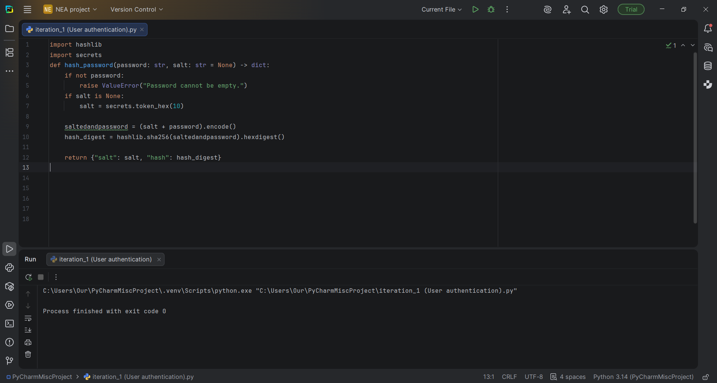

Testing:
Ive ran 4 tests in which they involve testing the hashing function by proving 4 outputs.
- Same password + same salt = same hash
- Same password + different salt = different hash
- Wrong password + same salt = different hash
- An empty password gives a validation error e.g. ValueError
Testing 1.3.mp4

Assessment:
The result shows 4 output statements with each statement being marked as “Pass” indicating that the hashing algorithm does indeed work.

2 - Student Record Management

A student record management system was required to allow authorised users to create, store and manage student information within the system. This functionality is essential because it provides the foundation for storing student names and grades in later iterations. For this iteration student records were stored using python dictionaries and lists. Each student was assigned a unique identifier, which was used as a key within a dictionary to allow efficient retrieval and updating of records. This approach would ensure that student data can be accessed quickly without needing to search through the entire data set, making the system more scalable.

Iteration 2.1

Objective:
Allows authorised users to add new student records to the system. This functionality would be necessary as it enables students to manage their information on the system in the form of records. The algorithm for this iteration would collect a unique student ID and the student’s name via user input. These details are then validated and once they are validate the student record is stored in the system.

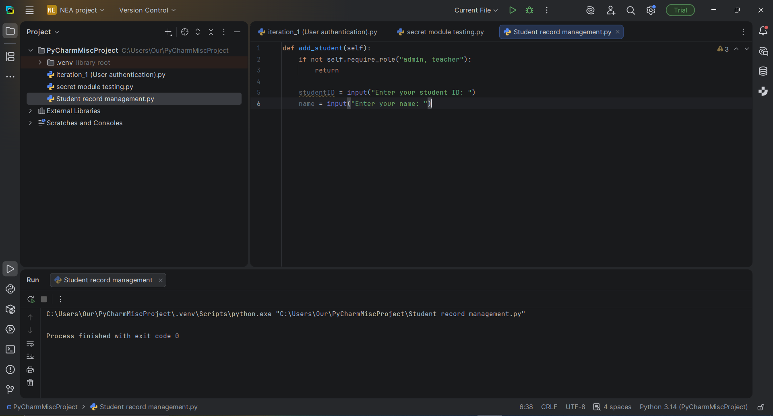

UPDATE:
On line 2 the if statement was coded not working as intended to. “ self.require_role(“admin, teacher”) ” is being used incorrectly because “require_role” expects a list, not a string. So instead of writing “

Testing:
Not needed
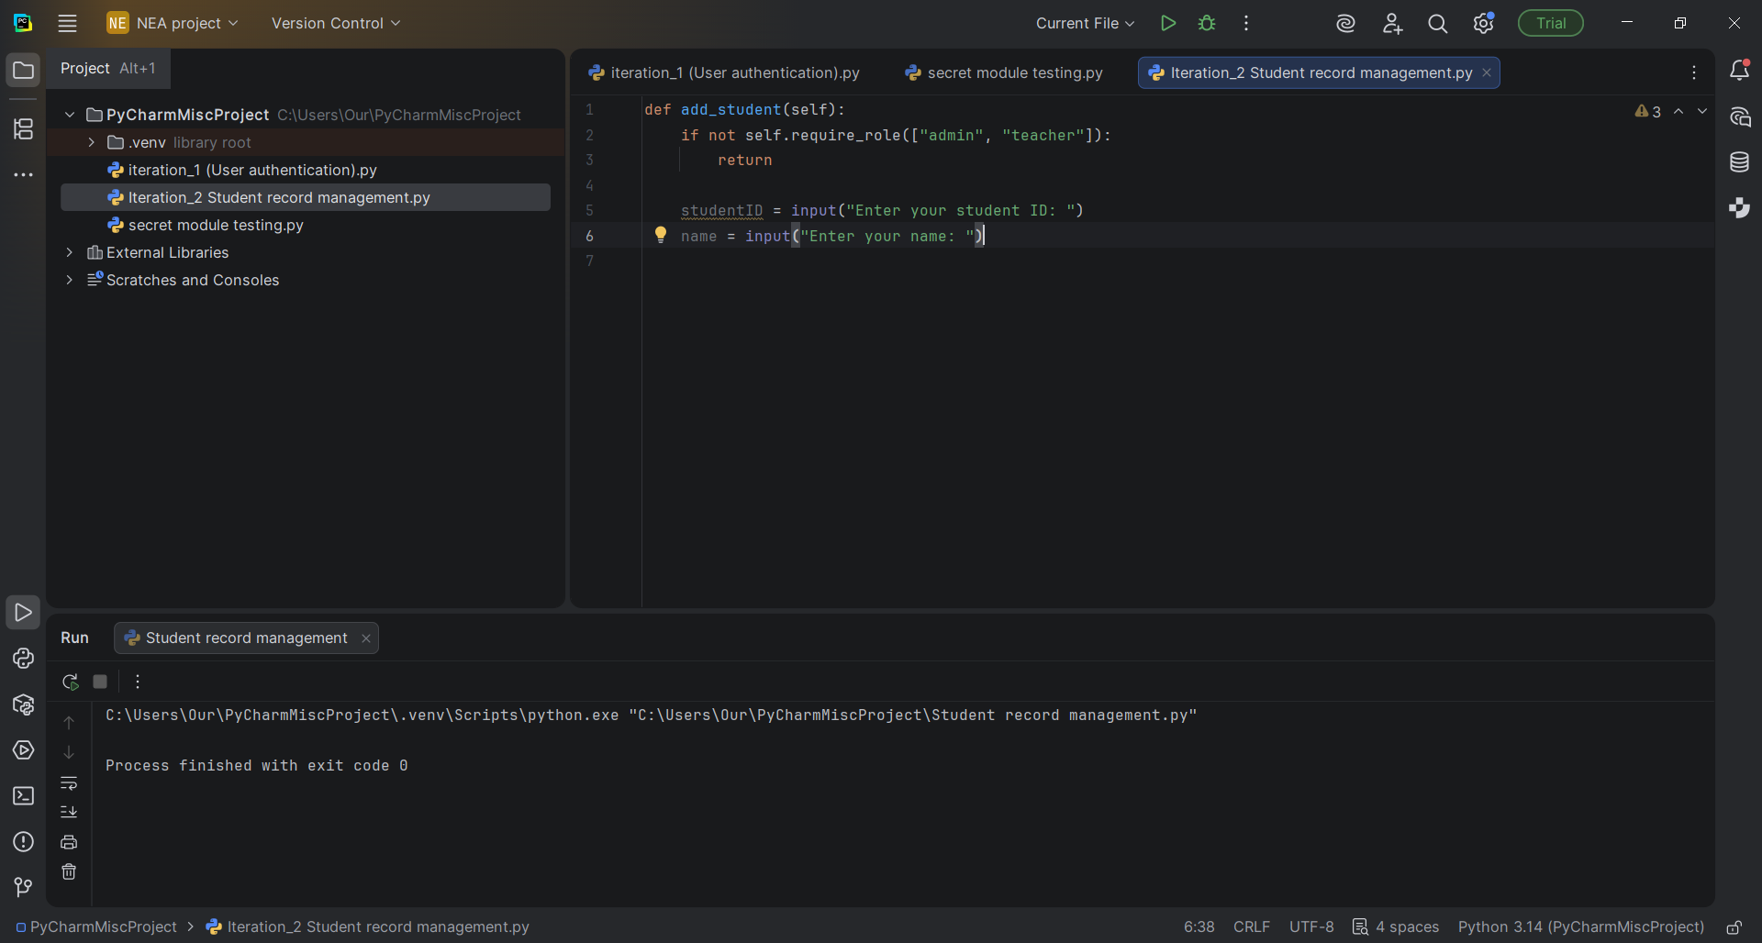

In the above image I've replaced self.require_role(“admin, teacher”) with “self.require_role([“admin”, “teacher”]). This makes it so the function in the system would get an assigned value in the form of a list rather than just a string of characters.

Assessment:
This is a good first iteration since it establishes the core data structures for the creation and storing of student records. Without this it would not be possible to implement features such as grade tracking or progress analysis for the later iterations.

Iteration 2.2

Objective:
For this iteration I have Improved the student record creation feature by adding data validation. Only authorised users (admins/teachers) can add students, duplicated student ID’s will be rejected to maintain data integrity and the new student record is stored in the system’s data structure and written to the data file using the “save()” method.

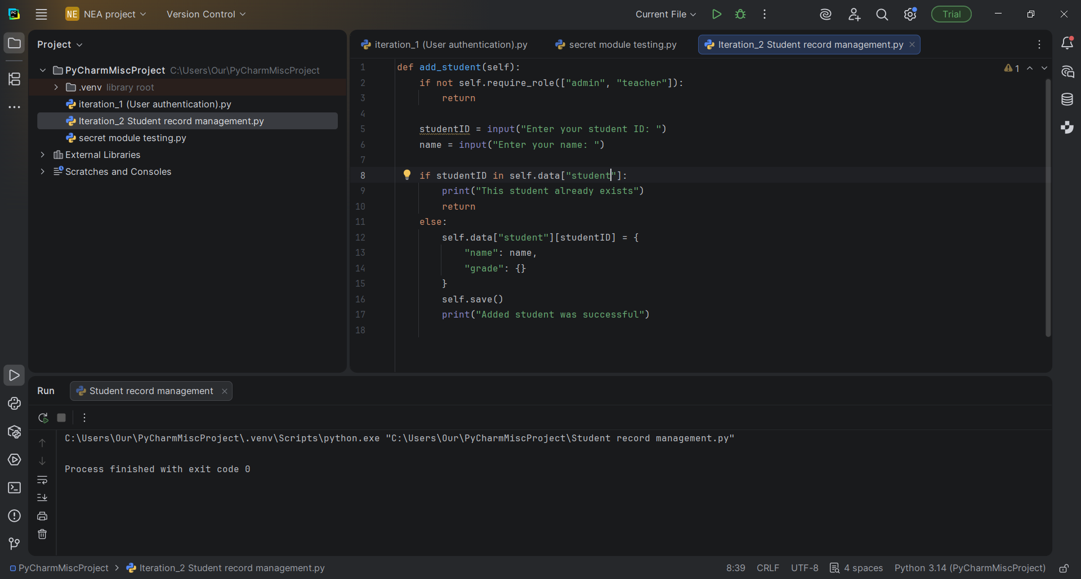

Testing:

(Testing authorisation)

Input | Expected output | Actual output/Pass condition
Logged in as teacher/admin, add student | Student saved successfully | Success message and student now appears in file
Logged in as student and tried to add student | Denied access / return without adding | Student was not added to file
Add a student with ID N745 and then try add the same student with that same ID | Printed output of “This student already exists” | Only one N745 record existing
blank ID or blank name | no record created | no record created
add student, close program, reopen | student record still remains | record appeared after reload

Major Update - (links with testing):
In order for this testing to actually work I've had to create an actual JSON file as part of the python system. SQLite was going to be my original database but I've decided to scrap that idea since it would’ve taken a huge chunk of my time to understand its own C programming language. Instead I've used JSON. With this I’ve had to implement a few more features within the code to make testing easier.

- Save function - It is part of the “system” class and is called using self.save() and basically works on the system’s internal data
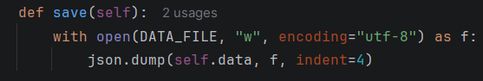
- Load function - All this function does is check if data.json actually exists and will prevent errors if the program is ran for the first time, without this the program may crash if the file doesn’t exist.
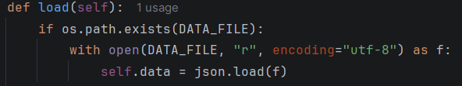
- Require role function - Only allows user with the appropriate role such as an admin or teacher, to perform sensitive actions like adding or modifying student records. It also prevents unauthorised access. This function is one of the most important functions even in the upcoming later iterations because it models real school systems, protects data integrity, prevents student malpractice and also enforces access control
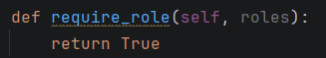

Updated iteration code:
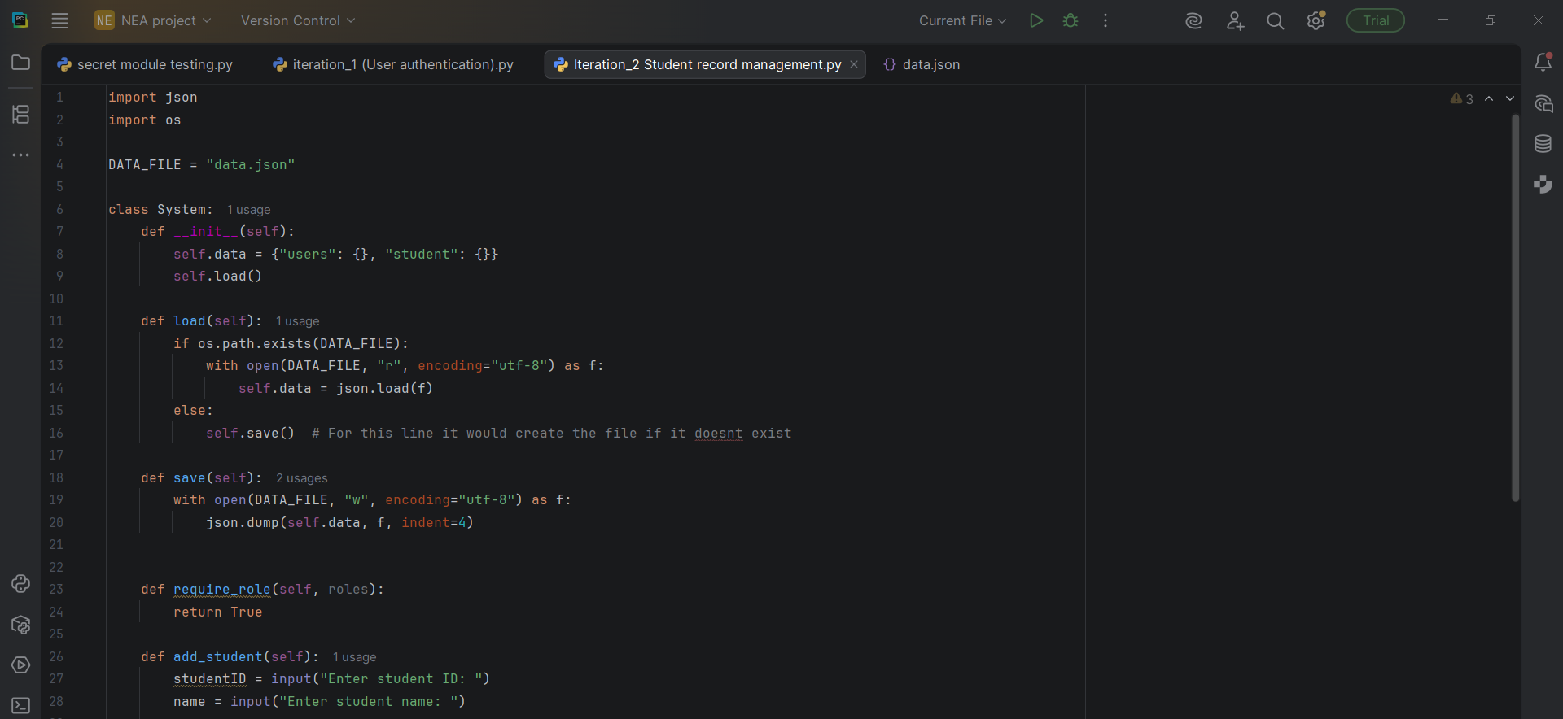
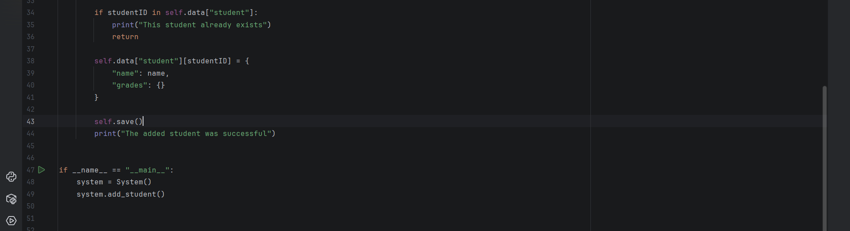

Assessment:

The iteration improves the system overall performance and allows for better system usage. It adds new student records while preventing duplicate entries but initial testing showed that the function was not being executed because there was no main entry point.

Iteration 2.3

Objective:
This iteration will allow authorised users to view stored student records. This means that the system would not only store the data but will also retrieve and display it. I implemented a view_students() method to allow authorised users to display existing student records. The system would then loop through the dictionary and print each student’s ID and name.
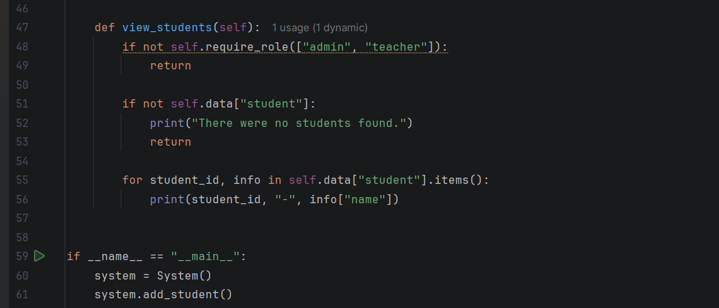

Testing:

Type of Input | Input | Expected output | Actual output
View students | 2 different students exist | Both students will be displayed | Student records were displayed correctly with their ID’s and names
View students (empty) | students = {} | No students found | “There were no students found”
Blocked student | role = student | Access denied | Access denied
Teacher/admin allowed | role = teacher/admin | Student list displayed | Students records were displayed
Persistence | restart program | students still displayed | Students records were displayed without any changes to the data

Assessment:
This iteration helped with system security and prevented record data loss.

Iteration 3.1:

Objective:
This iteration aims to allow admins/teachers to add a grade for a specific student. This feature would be required as this would be the main part of the system itself.

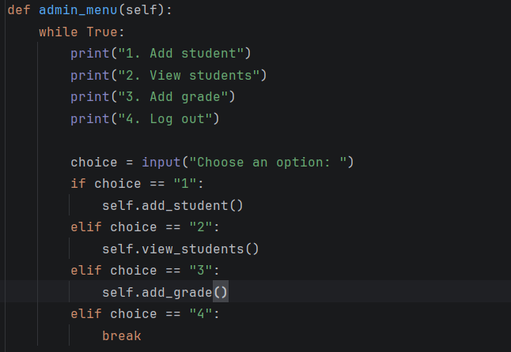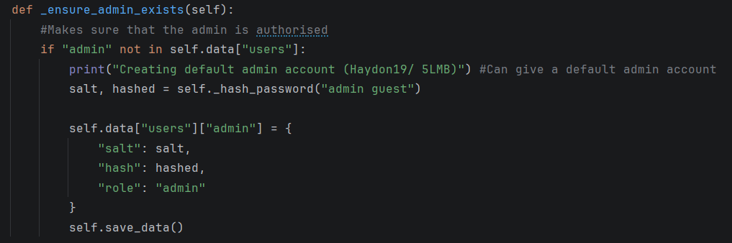
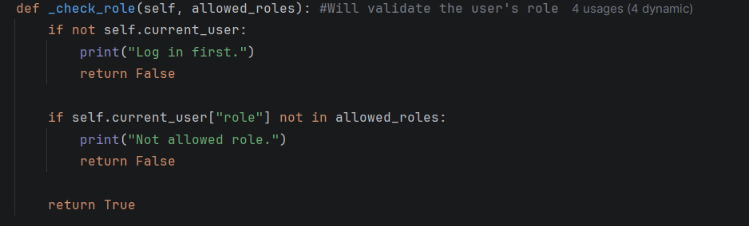
Once the user gets logged in, the system checks the role of the user. If user is an administrator, the program will enter into the admin menu loop which will display the available options to the user and receive his/her input until he/she logs out. This design enhances usability. It also allows multiple actions to be executed at once which makes the system much more efficient. 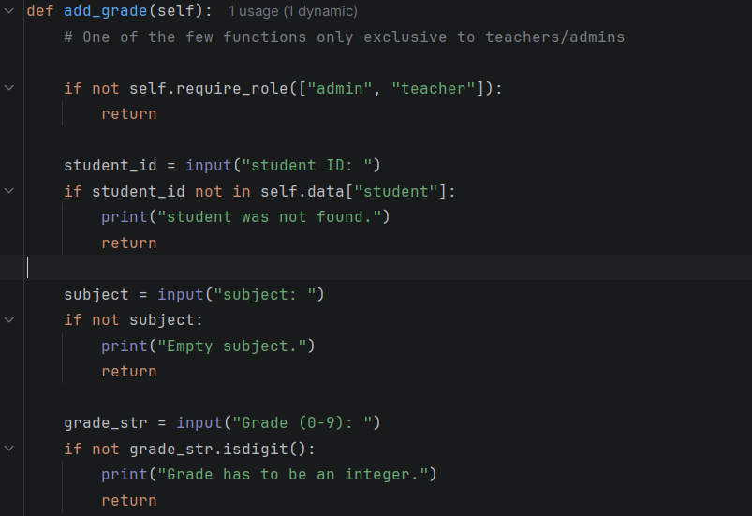

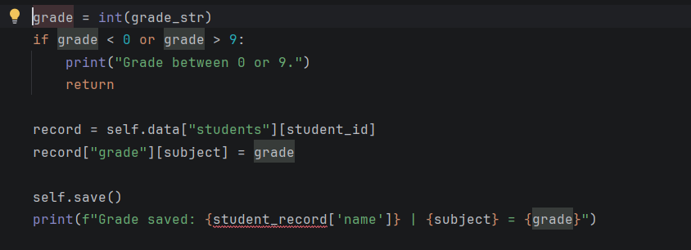

Review:
This iteration helped with further development such as viewing grades and calculating them. It unfortunately doesn't display performance statistics or report generations.

D. Evaluation

Effectiveness/Efficacy:
Overall the system successfully meets the main objectives identified in the analysis section. It allows authorised users to securely log in, manage student records, and record grades. Data is stored persistently using a JSON file and information is not lost between program executions. The system was developed iteratively and each iteration improved the system's functionality.

User and stakeholder requirements:
The system meets the needs of teachers, admins and students with admins and teachers being able to add and view student records whilst the access control prevents unauthorised users from modifying the data. This also reflects how a real school system restricts access based on roles. However students do have limited access but the system’s structure allows for future expansion.

Solution Highlights:
One highlight is that the use of role based access improves security by ensuring only authorised users can perform certain actions. Another highlight is the use of JSON for storage that is easy to integrate with python dictionaries. Input validation throughout the system reduces risk in invalid data being passed through due to duplicate students or out of range grades.

Solution limitations:
The system uses a command line interface so this may not be intuitive for non technical users. Grades are stored as simple numerical values without advanced analysis such as progress tracking over time. The system relies on a JSON file which wont scale well for large datasets or multiple concurrent users.

Possible improvements:
If my system were to be developed even further a GUI could be implemented to improve usability. Additional features such as editing or deleting student record records could also be added. Grade analysis tools such as calculating a student’s average grade would make the system more useful for teachers and students. A database such as SQLite could replace JSON to improve scalability.

Conclusion:
The system provides a functional solution to the problem of managing student records and grades. At its current state it is appropriate for its intended use.

Project Appendixes

Transcript for interviews:
Q1. What type of student information do you need quick access to frequently?
I would like to be able to access students’ grade information

Q2. How would you like to input or update student information?
I would like a system that enables

Q3. How important do you think data security is for your role?
Very important as some student information must be kept confidential so that other students

Q4. Would you rather have a simple interface with core features or a system with a variety of options?
Core features.

Q1. Do you think being able to communicate with teachers or view feedback from them would be beneficial?
Being able to view feedback from teachers would help students asses what they are doing right as well as what they are not doing right. This would cut down on the continual need to ask the teacher in person, enabling students to keep track of their progress.

Q2. What information would you like to check in your profile e.g. Grades/ progress
Students are interested in viewing their grades over various subjects, overall assessment over time, and written comments by the teachers. Looking at previous grades can assist in discovering strengths and weaknesses.

Q3. What kind of design would be better for you (mobile user friendly/ clean layout/ PC user friendly)
The layout should be clean and simple, clear menus, and not cluttered. Having mobile access would also be useful as students could just check their grades on their phones.

Q1. How should the data be stored (cloud/ local database)
For a small-scale system, a local database would be sufficient as it is easier to manage and does not rely on an internet connection. Cloud storage may be considered for larger systems but introduces additional complexity and security concerns.

Q2. Do you want to control the levels of access
Yes, access control is very important. Different users should have different permissions, for example administrators managing users, teachers managing grades, and students only viewing their own information.

Q3.What problems have you encountered with other similar systems such as SIMS
Existing systems can be overly complex, slow to navigate, and difficult to maintain. Some systems include unnecessary features that make simple tasks more time-consuming.

Q4. Do you prefer systems that are easy to maintain or complex systems with more features
An easy-to-maintain system is preferred, especially for schools with limited technical staff. A simpler system with essential features is more reliable and easier to update or fix.

Code listing:

Hash algorithm

DATA_FILE = "data.json"
import hashlib
import json
import os
import secrets

def hash_password(password: str, salt: str = None) -> dict:
if not password:
raise ValueError("Password cannot be empty.")
if salt is None:
salt = secrets.token_hex(10)
saltedandpassword = (salt + password).encode()
hash_digest = hashlib.sha256(saltedandpassword).hexdigest()
return {"salt": salt, "hash": hash_digest}

“secrets” module testing

import secrets
print(secrets.token_hex(10))
print(secrets.token_hex(10))

student record management

import json
import os
DATA_FILE = "data.json"
class System:
def __init__(self):
self.data = {"users": {}, "student": {}}
self.load()
def load(self):
if os.path.exists(DATA_FILE):
with open(DATA_FILE, "r", encoding="utf-8") as f:
self.data = json.load(f) #Without this the program may crash if the file doesn’t exist.
else:
self.save()
def save(self):
with open(DATA_FILE, "w", encoding="utf-8") as f:
json.dump(self.data, f, indent=4) #This would work on the systems internal data
def require_role(self, roles):
return True # One of if not the most important function since it prevents student malpractice
def add_student(self):
studentID = input("Enter student ID: ")
name = input("Enter student name: ")
if not studentID or not name:
print("Student ID and name cannot be empty.")
return
if studentID in self.data["student"]:
print("This student already exists")
return
self.data["student"][studentID] = {
"name": name,
"grades": {}
}
self.save()
print("The added student was successful")
def view_students(self):
if not self.require_role(["admin", "teacher"]):
return
if not self.data["student"]:
print("There were no students found.")
return
for student_id, info in self.data["student"].items():
print(student_id, "-", info["name"])
if __name__ == "__main__":
system = System()
system.add_student()

Further extension (grade management)

def add_grade(self):
# One of the few functions only exclusive to teachers/admins
if not self.require_role(["admin", "teacher"]):
return
student_id = input("student ID: ")
if student_id not in self.data["student"]:
print("student was not found.")
return
subject = input("subject: ")
if not subject:
print("Empty subject.")
return
grade_str = input("Grade (0-9): ")
if not grade_str.isdigit():
print("Grade has to be an integer.")
return
grade = int(grade_str)
if grade < 0 or grade > 9:
print("Grade between 0 or 9.")
return
record = self.data["students"][student_id]
record["grade"][subject] = grade
self.save()
print(f"Grade saved: {student_record['name']} | {subject} = {grade}")

Admin menu (teachers/admins only)

def admin_menu(self):
while True:
print("1. Add student")
print("2. View students")
print("3. Add grade")
print("4. Log out")
choice = input("Choose an option: ")
if choice == "1":
self.add_student()
elif choice == "2":
self.view_students()
elif choice == "3":
self.add_grade()
elif choice == "4":
break

JSON file (initial)

{
"users": {},
"student": {}
}

Final code (refined and updated):
import json
import os
import hashlib
import secrets
DATA_FILE = "data.json"

class System:
def __init__(self):
self.data = {"users": {}, "student": {}}
self.load()
#Storing main attributes
def load(self):
if os.path.exists(DATA_FILE):
with open(DATA_FILE, "r", encoding="utf-8") as f:
#Checks if the data file is actually existing
self.data = json.load(f)
else:
self.save()
def save(self):
with open(DATA_FILE, "w", encoding="utf-8") as f:
json.dump(self.data, f, indent=4)
def require_role(self, roles):
# One of if not the most important function since it prevents student malpractice
return True

def admin_menu(self):
#Admin menu function
while True:
print("1. Add a student")
# Allows for user input when wanting to add a student
print("2. View students")
#Allows for user input when wanting to view the students that are currently in the data.json record
print("3. Add grade")
#Allows for user input when wanting to add a grade
print("4. Log out")
#User is able to exit

choice = input("Choose an option: ") #User has to pick a choice between 1 and 4
if choice == "1":
self.add_student()
elif choice == "2":
self.view_students()
elif choice == "3":
self.add_grade()
elif choice == "4":
break
def add_student(self):
student_id = input("Enter student ID: ") #Makes it so that the user can add a student ID for the added student

#User can enter the student's ID
name = input("Enter student name: ")
#User can enter the student's name

if not student_id or not name:
print("Student ID and name cannot be empty.")

#If there isnt a student ID or name the program will return

return

if student_id in self.data["student"]:
print("This student already exists.")
#This allows for non duplicates of the same student
return
self.data["student"][student_id] = {
"name": name,
"grades": {}
}
self.save()
print("The student was added successfully.")

def view_students(self):
if not self.require_role(["admin", "teacher"]):
return
if not self.data["student"]:
#If the student an admin or teacher searched for wasnt in the record the below print statement is printed out
print("There were no students found.")
return
for student_id, info in self.data["student"].items():
print(student_id, "-", info["name"])

def add_grade(self):
if not self.require_role(["admin", "teacher"]):
return
# Functions above are exclusive to teachers/admins
student_id = input("Student ID: ")
if student_id not in self.data["student"]:
print("Student was not found.")
return

subject = input("Subject: ")
if not subject:
print("Empty subject.")
return

grade_str = input("Grade (0-9): ")
#Below if statement mmakes sure that the grade must be an integer
if not grade_str.isdigit():
print("Grade has to be an integer.")
return

grade = int(grade_str)
if grade < 0 or grade > 9:
print("Grade must be between 0 and 9.")
#Grrade must be between 0 and 0 as thats the minumum and maximum grade that they can store for a gcse student
return

record = self.data["student"][student_id]
record["grades"][subject] = grade

self.save()
print(f"Grade saved: {record['name']} | {subject} = {grade}")

def hash_password(password: str, salt: str = None) -> dict:
if not password:
raise ValueError("Password cannot be empty.") #If the password is empty the value error is raised

if salt is None:
salt = secrets.token_hex(10)

salted_password = (salt + password).encode()
hash_digest = hashlib.sha256(salted_password).hexdigest()

return {"salt": salt, "hash": hash_digest}

if __name__ == "__main__":
system = System()
#Stored system as the variable
system.admin_menu()
#Allows the sytem to actually run

def _ensure_admin_exists(self):
#Makes sure that the admin is authorised
if "admin" not in self.data["users"]:
print("Creating default admin account (Haydon19/ 5LMB)") #Can give a default admin account
salt, hashed = self._hash_password("admin guest")

self.data["users"]["admin"] = {
"salt": salt,
"hash": hashed,
"role": "admin"
}
self.save_data()

def login(self):
username = input("username: ")
#User can give there username

password = input("Password: ")
user = self.data["users"].get(username)
if not user:
# If the user doesnt exist then its returned
print("That user doesn't exist.")
return

salt = user["salt"] # Gives the user the salt

#The function below ensures that the hash password would contain the password and the salt
_, hashed = self._hash_password(password, salt)

if hashed == user["hash"]:
self.current_user = {
"username": username,
"role": user["role"]
}
print(f"Welcome back, {username}!")
else:
print("Incorrect password.")

def logout(self):
print("Logging out...")
#User can now logout whenever they want
self.current_user = None

def add_student(self):
#Can add the student
if not self._check_role(["admin", "teacher"]): #Making sure that the role is an admin or a teacher role.
#Will return
return

student_id = input("Student ID: ")
#Gives student id an input
name = str(input("Student name: ")) #Gives the name an input

if student_id in self.data["student"]: #Verifies that the student ID is stored in the actual record
print("There is already a student wth that same ID.")
#Prints that there is already an existing student with that same ID allowing for the user to check there mistype
return

self.data["student"][student_id] = {
"name": name,
"grades": {}
}

self.save_data()
print("Student added.")

def view_students(self):
if not self._check_role(["admin", "teacher"]): #Does not allow authorised access for people who dont have the role of an admin or teacher
return

if not self.data["student"]:
print("No student is in the system yet.")
return

def add_grade(self):
if not self._check_role(["admin", "teacher"]):
return

student_id = input("Student ID: ")
student = self.data["student"].get(student_id)

if not student:
print("Student was not found.")
return

subject = input("Subject: ")
grade_input = input("Grade (0-9): ")

try:
grade = int(grade_input)
except ValueError:
#Grade is an integer
print("Grade must be a number.")
#An integer input must be made
return

if grade < 0 or grade > 9:
print("Grade must be between 0 and 9.")
return

student["grades"][subject] = grade
#Student grades have now been saved

self.save_data()
#Saves student grade and subject data

print("Grade saved.") #Gives a statement saying that their grade was saved

def view_grades(self):
if not self._check_role(["admin", "teacher"]):
return
student_id = input("Student ID: ")
student = self.data["student"].get(student_id)

if not student:
#Returns and gives the statement that no grades were found
print("Student not found.")
return
if not student["grades"]:
print("No grades recorded.")

return
total = 0# The total will start as 0

count = 0#The count will start from zero

for subject, grade in student["grades"].items():
print(f"- {subject}: {grade}")
total = total + grade

count = count + 1
#The count will then increment by 1 whenever the function is returned

avg = total / count

#Can give an average of their subject grade
print(avg)
def _check_role(self, allowed_roles): #Will validate the user's role
if not self.current_user:
print("Log in first.")
return False

if self.current_user["role"] not in allowed_roles:
print("Not allowed role.")
return False

return True

def show_main_menu(self):
print("1. Login") #Main menu is shown to user

print("2. Exit")

choice = input("Choose option: ")

if choice == "1":
self.login()

elif choice == "2":
system.exit()

else:
print("Not an option.")

def show_user_menu(self): #User has their own menu displayed to them
print("1. Add student")
print("2. View students")
print("3. Add grade")
print("4. View grades")
print("5. Logout")

choice = input("Choose an option: ")

#The user is able to pick any number between 1 and 4 to give a choice
if choice == "1":

self.add_student()

elif choice == "2":
self.view_students()
elif choice == "3":
self.add_grade()
elif choice == "4":
self.view_grades()
elif choice == "5":
self.logout()
else:
print("Invalid option.")

def run(self):
while True:
if self.current_user:
self.show_user_menu()
else:
self.show_main_menu()

if __name__ == "__main__":
project = SGMS()
#System gets to run now
SGMS.run()
#

Links:
W3schools,
Youtube Links:
BroCode, Coding with lewis, programming with mosh, fireship, lucid software, freecodecamp.org, Dr Daniel Soper, Adam Finer,

